Clinical Information Pack

Associate Professor

|  |  |  |  |
| --- | --- | --- | --- |
| Post title: | **Associate Professor in Medical Oncology** | | |
| School: | Cancer Sciences | | |
| Faculty: | Faculty of Medicine (FoM) | | |
| Career Pathway: | Clinical | Level: | Consultant |
| Salary: | £105,504 | To | £139,882 |
| Total number of PA’s | 10 | | |
| Associated NHS Trust | University Hospital Southampton NHS Foundation Trust (UHS) | | |
| Clinical category: | Balanced portfolio | | |
| Posts responsible to: | Deputy Head of School (Clinical)  UHS Cancer Care Clinical Lead (for clinical duties) | | |
| Posts responsible for: | Research Staff and Postgraduate Research Students as appropriate | | |

**Particulars of Appointment**

The Faculty of Medicine supported by University Hospital Southampton NHS Foundation Trust wishes to appoint an Associate Professor in Medical Oncology with special interest in gastrointestinal oncology. The successful candidate will be someone who has won prestigious external fellowship funding and has demonstrable potential to acquire further independent funding.

This academic post will function within the School of Cancer Sciences [https://www.southampton.ac.uk/about/faculties-schools-departments/school-of-cancer-sciences], based in modern purpose built premises on the Southampton General Hospital Campus. The successful candidate will have a strong record of research and publication and will be expected to develop their own programme of research with support from clinical and laboratory-based colleagues, winning support from major national funding bodies.  It is expected that the person appointed will contribute to the academic leadership within the Faculty and enhance the quality of our research, enterprise and teaching.

Clinical duties will enhance the existing practice of Medicine within UHS.

The post is subject to terms and conditions of service determined by the University of Southampton and in its honorary clinical consultant capacity by University Hospital Southampton Foundation Trust Board.

**The University of Southampton**

The University of Southampton is a leading research-intensive University, a member of the Russell Group and one of the top 100 universities worldwide. We deliver an excellent educational experience, world-leading research and we are known for successfully commercialising that research through enterprise.

This is an exciting time to join the University of Southampton. We have an aspirational University Strategy (see [www.southampton.ac.uk/strategy](http://www.southampton.ac.uk/strategy)), setting out our ambitions over the next five years. The strategy involves achieving a top 10 place in the UK for research, which we will achieve by investing in the highest quality staff and facilities. We are also transforming the education offer available to undergraduate and postgraduate students across the University, providing greater flexibility and modular courses, with a strong international focus. The University are making significant investment in the Southampton General Hospital Campus, building a new multi-disciplinary Institute of Medical Innovation.

**The Faculty of Medicine**

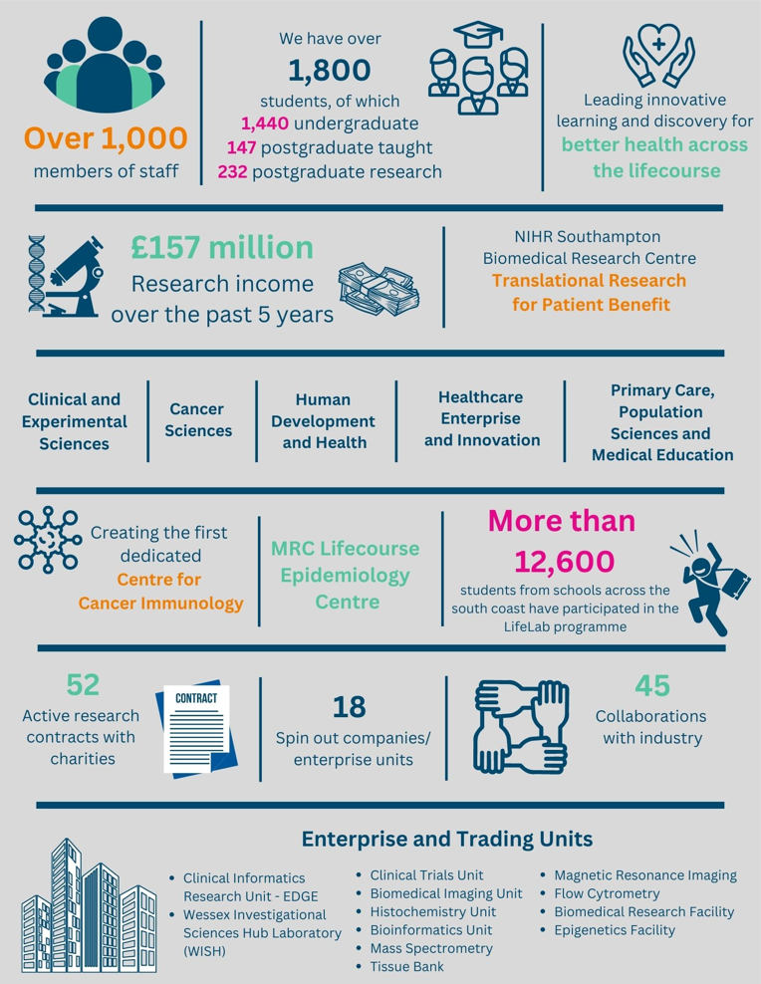

The creation of the Faculty of Medicine has enabled us to build upon strong foundations of basic research and clinical translation.  Working with colleagues across the University and in the local NHS we have strengthened our position as a renowned centre for translational research, leading innovative learning and discovery for better health across the life-course.  In this context, we are looking to appoint an outstanding senior academic to develop and lead a major programme of funded clinical research in the field of interstitial lung disease.

Key to the success of the Faculty of Medicine is the delivery of high-quality education for undergraduate and postgraduate students, building on our partnership in biomedical research with University Hospital Southampton NHS Foundation Trust and fostering new collaborations with the physical sciences, including chemistry, engineering and computing. The new senior academic in oncology will play a key role in these developments.

The Faculty will celebrate its 50th anniversary in 2026. In 1971 FoM consisted of 40 students. FoM is now reputed for its excellence in research, innovative clinical teaching and is a vibrant pillar of the South of England community.

**The Student Experience**

We offer a range of undergraduate programmes: the BM4 programme, a graduate-entry four-year programme which accepts 48 students per year; and the BM5 and BMedSc programme which accepts 200 students per year including approximately 30 students from a BM6 programme aimed at widening access to a medical career. Students also join the first two years for teaching in Southampton on the BM(EU) Programme, an affiliation with a German Medical school in Kassel. Biomedical/ Psychosocial Teaching in the first two years of the BM programmes is delivered in the South Block of Southampton General Hospital as well as on Highfield campus. Clinical teaching takes place at Southampton General Hospital and the adjoining Princess Anne Hospital, the Royal South Hants Hospital, and in NHS Trusts and General Practices throughout Hampshire, Dorset, West Sussex and Salisbury.

The BM5 programme has a number of distinctive features.   These include the integrated nature of teaching where the scientific disciplines are taught together in a clinical context using a systems-based approach and the BMedSc programme, a four-month supervised research project undertaken in Year 3. There is also the opportunity, for selected students, to undertake an integrated, intercalated Masters in Medical Science (MMedSc).  The BM4 programme also has several key features.  These include clinical topics in the first two years where students meet on a regular basis in Graduate Groups and learning with BM5 students in the third and fourth years on all clinical attachments.  All students take the same final examinations.  All programmes have substantial clinical experience in the first two years, student selected components, dispersed final year attachments, work shadowing prior to commencing a Foundation post and inter-professional learning.  The Faculty will launch a new BM curriculum in 2025

In addition to the undergraduate BM programmes the School provides four Masters Degree programmes in Public Health, Allergy, Biomedical Sciences, Genomics, Cancer Biology and Immunology. A Master’s of Innovation: Medical Technology, Innovation and Design will launch in the 2025 academic year.

**Research and Enterprise**

The Faculty of Medicine has a clear research strategy to investigate the biomedical basis of common human diseases and to translate this into clinical practice. All research undertaken within the Faculty has clear evidence of international excellence and is delivered through appropriate Faculty Schools.

The Faculty of Medicine Enterprise Strategy is fully aligned to the University Enterprise Strategy to provide a step change to its enterprise and innovation culture, delivering global outreach, community engagement, innovative healthcare and policy. We work with all stakeholders from industry and pharma to health providers and the community.

**Equality, Diversity and Inclusivity**

We are committed to positively advancing equality of opportunity. We participate in a number of equality initiatives which celebrate good employment practice for the advancement of diversity, equality and inclusivity. These include the Stonewall Workplace Equality Index, the Race Equality Charter and Athena Swan, (for which we are currently silver award holders). We also have a number of staff equality committees who champion the advancement of equalities for diverse groups. The Faculty holds a Silver Athena Swan award and will be seeking Gold status next year.



**Southampton Behaviours**

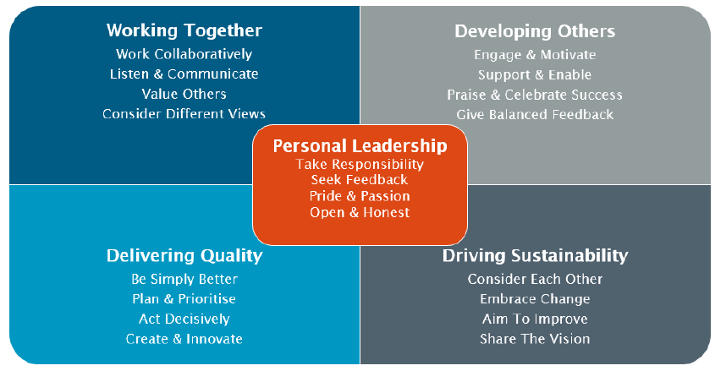

**School Information**

**Cancer Sciences (CS)**

The medically qualified post-holder will join a large team of basic and clinical researchers in Cancer Sciences which host extensive programmes in translational cancer medicine and discovery.

Cancer Sciences of the Faculty of Medicine consists of over 150 scientists, clinicians and associated staff with a research budget in excess of £7m/annum, under the present leadership of Professor Jon Strefford. Major infrastructure support comes from the National Institute of Health and Care Research and Cancer Research UK (CRUK) via the Experimental Cancer Medicine Centre and Clinical Trials Unit. The Somers Cancer Research Building was constructed in 2001 and houses laboratory research in cell and molecular biology. The Southampton Centre for Cancer Immunology was constructed in 2017 and houses research in immunology as well as the Clinical Trials Unit. The mission has always focused on bringing together excellent clinical and basic research and delivering high quality translational research for improving cancer treatment. Our current identified research strengths focus on cancer immunology and immunotherapy, the molecular mechanisms of malignancy and the tumour microenvironment closely allied to the clinical practice in cancer treatment within the Southampton Cancer Centre. All the groups within the Unit, while based at the General Hospital Campus, have strong collaborative links with the basic medical science groups and others on the main University Campus. Within the clinical service there are large, well-organised multidisciplinary practices in the common malignancies and also in areas of particular expertise in non-surgical oncology (haematological malignancy, urological cancer, paediatric malignancy). The strategy is to concentrate on the areas of greatest potential overlap.

Translation is supported by broad expertise in preclinical models and extensive collaborations with biotech/pharma. The science is strengthened by links to groups across the University with expertise in physical sciences, mathematics and data science, and collaborations with Centres across the CRUK network and internationally.

Translational interfaces are focused on lymphoid malignancies, oesophageal, colorectal, lung, head and neck and breast cancers, reflecting tumour types of priority to CRUK, areas of strength in clinical research and our recognised opinion leaders. Our clinical academics lead international practice-changing trials and a range of studies to understand cancer biology in detail, supported by the CRUK/NIHR Experimental Cancer Medicine Centre and Clinical Trials Unit.

Recent strategic developments have focused on early cancer diagnosis research, in partnership with the NIHR Biomedical Research Centre(BRC) Respiratory Medicine theme and the School of Primary Care, and on data science and molecular phenotyping, bringing together a collaboration of the Data, Health and Society theme of the BRC, the Social Data Foundation(a partnership of University, NHS-Trust and City-Council), our UKRI-Trustworthy Autonomous-Systems-Hub and the School-of-Health-Sciences expertise in the communication of risk.

**Principal research themes include**

* Antibody therapeutics: Immunomodulatory and antibody-drug conjugates
* Antigen processing and immunomodulation
* B-cell malignancies
* Tumour microenvironment: Cancer associated macrophages and fibroblasts
* Healthcare data and molecular phenotyping: Large scale data integration
* Improving understanding and communication of cancer risk**.**

Candidates are encouraged to have conversations with theme leads to explore project ideas and proposals. Information can be provided by contacting Professor Andrew Davies ([a.davies@southampton.ac.uk](mailto:a.davies@southampton.ac.uk)) who will be able to help direct these.

**Staff**

**Cancer Sciences**

**Head: Professor Jon Strefford**

**Cancer Sciences at the University of Southampton: Clinical Academics**

The academic team is fully integrated with the NHS oncology department, and all the site-specialist clinics run with joint medical/radiation oncology input. More than half the Consultants in Oncology run practices at other hospitals in the Network as well as Southampton, and there are large patient flows between the centre and the various units.

Professors:

Professor P W M Johnson CBE MD FRCP FMedSci, Medical Oncology

Professor A J Davies PhD FRCP, Professor of Haematological Oncology (Deputy Head of School (Clinical)

Professor F Forconi, Professor of Haematology

Professor J N Primrose MD FRCS FMedSci, Surgical Oncology

Professor D Eccles MD FRCP, Cancer Genetics

Professor S Lim, PhD MRCPath Professor of Haematology

Professor S Crabb PhD MRCP, Medical Oncology, Professor of Translational Oncology

Professor E Copson, Professor of Medical Oncology

Professor J Gray, Professor of Paediatric Oncology

Professor A Lucassen DPhil FRCP, Cancer Genetics

Professor G Thomas PhD FDSRCS, FRCPath, Experimental Pathology

Professor A Mirnezami PhD FRCS, Surgical Oncology (Colorectal)

Professor A P Williams PhD, MRCP FRCPath, Clinical Immunology

Professor Tim Underwood PhD FRCS, Professor of Gastrointestinal Surgery

Honorary Professor:

Professor R Cutress PhD FRCS, Surgical Oncology (Breast)

Associate Professors:

Dr A Bateman PhD MRCP FRCR, Clinical Oncology (Gastrointestinal)

Mrs E V King PhD, FRCS Surgical Oncology (Head and Neck)

Dr Ioannis Karydis PhD, MRCP, Medical Oncology (Melanoma)

Consultants with Honorary Academic appointments:

Dr M Ashton-Key, DM FRCPath, Histopathology

Dr D S Richardson MD FRCP FRCPath, Haematology

Dr P Simmonds FRACP, Medical Oncology

**Clinical Cancer Research Infrastructure in Southampton**

The Centre hosts the Wessex network of the NIHR Research Delivery Network (Cancer Clinical Lead, Dr Matthew Wheater) for a population of 3 million, which currently recruits over 20% of incident cancer cases into clinical trials.

There is close integration of the Network and the CR UK Clinical Research Unit which conducts early phase studies, with research nurses from the two teams cross-covering clinics and unified professional leadership through the CR UK Senior Research Nurse (Kerry Fitzpatrick).

The Southampton Clinical Trials Unit (Director: Professor Gareth Griffiths), has core funding from

CR UK and HTA. Since it was established in 2006 this has expanded its activity to include studies in Upper GI and Colorectal cancer, Lymphoma, Breast and Prostate cancer. The Unit benefits from the long-standing excellence in Clinical IT systems developed in the centre and is piloting remote data capture in the academic UK clinical trials arena. The CTU hosts a large portfolio of studies in early cancer diagnosis.

The Southampton Experimental Cancer Medicine Centre (Lead: Professor Andrew Davies), with an expanding portfolio of early phase trials, many testing reagents developed in the Southampton laboratories, and carrying out complex immunologic endpoint assays to GCLP in the purpose built laboratories of the Wessex Investigational Science Hub.

Location on the Southampton General Hospital campus, which includes the facilities of the Southampton Oncology Centre (Radiation Oncology, Medical Oncology and Clinical Haematology including level 4 transplantation) as well as the full range of general and tertiary specialist medical facilities, including neurosurgery, hepatobiliary and pancreatic surgery, cardiothoracic surgery, paediatric oncology, cellular pathology and molecular diagnostics.

A dedicated and fully staffed Clinical Research Facility is also located in the hospital adjacent to

the Oncology wards, for the conduct of early phase clinical trials work.

**University Hospital Southampton NHS Foundation Trust (UHS)**

University Hospital Southampton NHS Foundation Trust provides services to some 1.9 million people living in Southampton and South Hampshire, plus specialist services such as neurosciences, cardiac services and children's intensive care to more than 3.7 million people in central southern England and the Channel Islands.

The clinical lead for Cancer Care is Dr Matthew Jenner (matthew.jenner@uhs.nhs.uk) with Dr Sarah Ellis ([sarah.ellis@uhs.nhs.uk](mailto:sarah.ellis@uhs.nhs.uk)) leading for the Medical Oncology Group

The Trust is also a major centre for teaching and research in association with the University of Southampton and partners including the Medical Research Council and Wellcome Trust.

UHS gained Foundation Trust status on 1 October 2011.

Every year 11,500 UHS staff:

* treat around 150,000 inpatients and day patients, including about 50,000 emergency admissions;
* sees over 624,000 people at outpatient appointments; and
* deals with around 135,000 cases in the [emergency department](http://www.uhs.nhs.uk/OurServices/Emergencymedicine/EmergencyDepartment.aspx).

Providing these services costs £1.9 million a day.

Job Description and Person Specification

|  |
| --- |
| Job purpose |
| To undertake scholarly activity especially research in Medical Oncology in line with the School/Department research strategy, to teach at undergraduate and postgraduate level, and to undertake leadership, management and engagement activities and clinical commitments at University Hospitals Southampton NHS Foundation Trust (UHS). |

|  |  |  |
| --- | --- | --- |
| Key Research accountabilities | | % Time |
|  | Plan and coordinate a broad research programme and activity in an area of recognised excellence for the University. Act as principal investigator on projects, responsible for defining original research objectives, developing, and managing staff, and attracting funding through bids and reputation. Develop and oversee the application of innovative and creative research methodologies and techniques that add to the knowledge/understanding of the subject area.  Develop and sustain a national and international reputation for research and the enhancement of learning and teaching practice by the regular dissemination and explanation of findings through leading peer-reviewed publications, major conferences, or exhibiting work at other appropriate events. Engage in external academic activities in accordance with the School’s research strategy and which enhance the School’s national/international research profile, e.g. membership of committees of academic bodies, external examining, journal editorships, etc.  Manage administrative tasks associated with specified research funding, including risk assessment of programme activities, leading project meetings and preparation of annual reports. Management of procedures required to ensure accurate and timely formal reporting and financial control. | 35% |
|  | Key Education accountabilities |  |
|  | Contribute to the development of teaching and learning activities of the School. Deliver teaching of the highest quality across a range of modules and to all levels, through lectures, tutorials, practical and seminars.  Take responsibility for overseeing, developing, and promoting fresh teaching and learning approaches and material, which create interest, understanding and enthusiasm amongst students. Directly supervise students, providing expert advice on learning best practice and helping with learning problems. Identify the learning needs of students and define learning objectives. Promote the use of appropriate media to support student learning. Set and mark coursework and exams, providing constructive feedback to students.  Design, develop and deliver an innovative range of programmes and study, sometimes for entirely new courses at various levels. Take responsibility for the quality of the design of existing courses and programmes, continually monitoring, evaluating, and revising them to ensure excellence and coherence, identifying areas where current provision is in need of revision or improvement.  Contribute to the development of research, teaching and learning strategies in the School. | 10% |

|  |  |  |
| --- | --- | --- |
|  | Key Management, Leadership and Engagement accountabilities |  |
|  | Provide expert advice and subject leadership to other staff and students, including research supervision.  Take on appropriate School coordinating roles to advance student academic development, e.g., act as Senior Tutor, Head of Teaching Programme, Coordinator of Programmes at undergraduate or postgraduate levels, etc.  Represent the School/Faculty/University in the disciplinary community externally.  Any other duties as allocated by the line manager following consultation with the post holder. | 5% |
| Key Clinical accountabilities | | % Time |
| Clinical academic staff are managerially accountable for their clinical duties to the designated Clinical Lead for Medical Oncology services within University Hospital Southampton NHS Foundation Trust (and successor organisations).  The Job Plan will be discussed and implemented following discussions with Clinical Lead.  The post holder will undergo annual joint academic-clinical appraisal and performance review.  Participate in audit, clinical effectiveness and clinical governance initiatives as required by the Trust and commissioners.  Share supervision of junior medical staff with consultant colleagues.  Participate as an honorary consultant in Medical Oncology within University Hospital Southampton NHS Foundation Trust (or successor organisation).  Participate in continuing medical education and continuous professional development. | | 50% |

|  |
| --- |
| Job Plan |
| This will be based on the standard 10 programmed activities (PA’s) of a consultant contract, to deliver 5 PAs in Medical Oncology to the clinical service provided by the Department.   |  |  | | --- | --- | | Medial Oncology DCC (Direct Clinical Care) including On call | 4 | | Medical Oncology SPA | 1 | | Total Weekly PA’s | 5 |   Proposed Job Plan Timetable   |  |  |  |  |  |  | | --- | --- | --- | --- | --- | --- | |  | **Monday** | **Tuesday** | **Wednesday** | **Thursday** | **Friday** | | **AM** | UGI Chemo clinic (1.25) | Acute Oncology post-take ward round (1.0) | HPB and Upper GI MDT (0.75) | UoS (1) | UoS (1) | | New/FU Clinic (0.5) | | **PM** | Admin (0.5) | SPA (1.0) | UoS (1.0) | UoS (1) | UoS (1) |   UoS: University of Southampton  The exact nature of the clinical PA’s to be undertaken will be agreed with the Trust within the job plan. Medical Oncology clinical liaison including MDT attendance and on-call Oncology clinical workload will be shared with NHS colleagues on a fair and equitable basis.  This job plan is provisional and may alter after discussion with the successful applicant at the start of the job. It is expected that the successful candidate will work with the management team to ensure that services are delivered efficiently and reflect best practice with processes and governance to match. The job plan will be reviewed annually, and any changes mutually agreed between the post holder, the Trust and the University.  *On-call Arrangements*  The exact nature of any on-call commitments to be undertaken will be agreed with the Trust within the job plan but will be expected to be a 1 in 8 on-call (evenings and weekends) with prospective cover.  *Annual Leave and Flexible Working Arrangements*  In line with annual leave entitlement, irregular work patterns and flexible working hours can be negotiated with the line manager. |

| Internal and External Relationships |
| --- |
| Member of the School/Department Board, Examination Board and of such School/Department committees relevant to their administrative duties.  New appointees will be assigned a senior colleague to guide their development and aid their integration into the School/Department and university.    Research priorities will be agreed within the strategic framework of the research theme of which they are a member.  Teaching and administrative duties will be allocated by the Head of School/Department, within the context of the teaching programmes agreed by the School/Department Learning and Teaching Committee.  Other key relationships;   * Research Colleagues; * Head of School/Deputy Head of School (Clinical) * Central University Offices/Professional Services (e.g. Graduate Office, Finance, Research and Innovation services etc.); * Delivery of research presentations at national/international conferences and meetings; * Peer review of research outputs for national/international journals. |

| Appraisal |
| --- |
| This will meet Royal College, GMC, and University guidelines, follows nationally agreed process with annual appraisals involving a UHS Trust appraiser and the University line manager or their nominees. This carries an expectation of active involvement in audit, continuing professional development and revalidation in line with best practice in clinical governance.  The UHS Trust has a range of mandatory training and competence initiatives which are reviewed on a regular basis. Appointees are required to register and participate in these programmes (mainly via e-learning and assessment). |

| Staff Benefits |
| --- |
| Working at the University of Southampton gives you access to a wide range of benefits in addition to our competitive rates of pay. Our core benefits include pension scheme membership; a generous annual leave allowance (supplemented by University closure days and public holidays) and excellent family leave arrangements (including maternity, paternity, adoption and parental leave).   * Faculty Mentoring Scheme; * Ability to remain in NHS pension scheme, subject to qualifying criteria; * Discounted Sport and Wellbeing membership; * Access to private dental and/or healthcare insurance; * Cycle to work scheme * Tax-Free childcare |

**Person Specification**

|  |  |  |  |
| --- | --- | --- | --- |
| Criteria | Essential | Desirable | How to be assessed |
| Qualifications, knowledge and experience | Primary medical qualification and full registration with the GMC or equivalent organisation  MRCP (UK) and FRCPath or equivalent  Certificate of completed specialist training in Medical Oncology  PhD or equivalent higher degree  Experience of relevant field of cancer research.  Track record of teaching at undergraduate and postgraduate level.  Extensive track record of published research  Track Record of winning Personal Research Fellowship Support from national funder | Evidence of a national and international reputation in cancer research  Teaching qualification (PCAP or equivalent)  Membership of Higher Education Academy Track record of developing and disseminating successful learning approaches  Involvement in national and international events | CV  Application  References  Interview |
| Planning and organising | Proven ability to plan and shape the direction of an area of research and teaching activity, ensuring plans complement broader research and education strategy.  Proven ability to develop innovative research proposals and attract research funding.  Proven ability to plan, manage, organise and assess own teaching contributions. | Able to build research/teaching teams.  Proven ability in the design of course units, curriculum development and new teaching approaches in the School, taking primary responsibility for their quality  Able to contribute to the development of research and teaching policy within the School. | CV  Application  References  Interview |
| Problem solving and initiative | Able to develop significant new concepts and original ideas within own field in response to intractable issues of importance to the research area |  | CV  Application  References  Interview |
| Management and teamwork | Able to mentor, manage, motivate and coordinate teaching/research teams, delegating effectively. Able to resolve performance issues and formulate staff development plans, where appropriate, to ensure team aims are met.  Able to foster and develop good relationships between own School and the rest of the university.  Able to monitor and manage resources and budgets.  Work effectively in a team, understanding the strengths and weaknesses of others to help teamwork development. | Proven ability to manage and deliver own course units and team-taught course units  Proven ability to coach, advise and support others (staff and students) on learning and teaching issues.  Able to work proactively with senior colleagues to develop cross-School and institution cooperation and effectiveness.  Able to contribute to the running of the School by managing significant School processes. | CV  Application  References  Interview |
| Communicating and influencing | Communicate new and complex information effectively, both verbally and in writing, engaging the interest and enthusiasm of the target audience.  Extensive track record of presenting research results at group meetings and conferences. | Able to engage counselling skills and pastoral care, where appropriate.  Able to persuade and influence at all levels in order to foster and maintain relationships, resolving tensions/difficulties as they arise.  Able to provide expert guidance to colleagues in own team, other work areas and institutions to develop understanding and resolve complex problems.  Able to negotiate for the School on key issues.  Able to develop and lead key communications strategies. | CV  Application  References  Interview |
| Other skills and behaviours | Compliance with relevant Health & Safety issue.  Positive attitude to colleagues and students. |  | CV  Application  References  Interview |
| Special requirements | Able to attend national and international conferences to present research results. |  | CV  Application  References  Interview |

**JOB HAZARD ANALYSIS**

**Is this an office-based post?**

|  |  |
| --- | --- |
| Yes | If this post is an office-based job with routine office hazards (eg: use of VDU), no further information needs to be supplied. Do not complete the section below. |
| No | If this post is not office-based or has some hazards other than routine office (eg: more than use of VDU) please complete the analysis below.  Hiring managers are asked to complete this section as accurately as possible to ensure the safety of the post-holder. |

## - HR will send a full PEHQ to all applicants for this position. Please note, if full health clearance is required for a role, this will apply to all individuals, including existing members of staff.

|  |  |  |  |
| --- | --- | --- | --- |
| **ENVIRONMENTAL EXPOSURES** | **Occasionally**  (<30% of time) | **Frequently**  (30-60% of time) | **Constantly**  (> 60% of time) |
| Outside work |  |  |  |
| Extremes of temperature (eg: fridge/ furnace) |  |  |  |
| ## Potential for exposure to body fluids |  | ✓ |  |
| ## Noise (greater than 80 dba - 8 hrs twa) |  |  |  |
| ## Exposure to hazardous substances (eg: solvents, liquids, dust, fumes, biohazards). Specify below: |  | ✓ |  |
| Frequent hand washing |  | ✓ |  |
| Ionising radiation | ✓ |  |  |
| **EQUIPMENT/TOOLS/MACHINES USED** | | | |
| ## Food handling |  |  |  |
| ## Driving university vehicles(eg: car/van/LGV/PCV) |  |  |  |
| ## Use of latex gloves (prohibited unless specific clinical necessity) |  |  |  |
| ## Vibrating tools (eg: strimmers, hammer drill, lawnmowers) |  |  |  |
| **PHYSICAL ABILITIES** | | | |
| Load manual handling |  |  |  |
| Repetitive crouching/kneeling/stooping |  |  |  |
| Repetitive pulling/pushing |  |  |  |
| Repetitive lifting |  |  |  |
| Standing for prolonged periods |  |  |  |
| Repetitive climbing (ie: steps, stools, ladders, stairs) |  |  |  |
| Fine motor grips (eg: pipetting) | ✓ |  |  |
| Gross motor grips |  |  |  |
| Repetitive reaching below shoulder height |  |  |  |
| Repetitive reaching at shoulder height |  |  |  |
| Repetitive reaching above shoulder height |  |  |  |
| **PSYCHOSOCIAL ISSUES** | | | |
| Face to face contact with public |  | ✓ |  |
| Lone working |  |  |  |
| ## Shift work/night work/on call duties |  | ✓ |  |